Brian Reber
CprE 381
Lab 02
Prelab:

5e)
entity loader is
port (big_wank : in std_logic_vector(5 downto 0);
net_tok : in std_logic;
tw_cnt : in std_logic;
clk : in std_logic;
assert : out std_logic;
data : out std_logic_vector(9 downto 0);
addr : out std_logic_vector(7 downto 0);
spud_out : out std_logic);
end loader;
6e)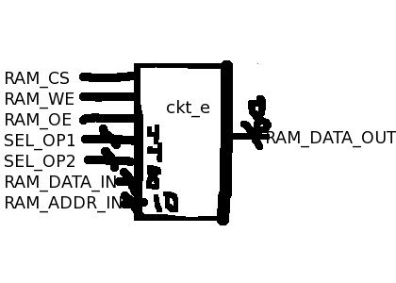
7) In the entity declaration in part a, there is a missing semicolon at the end of the clk line, and there is also a missing semicolon at the end of the port declaration. In part b, there is a missing closing parenthesis and semicolon for the port declaration.

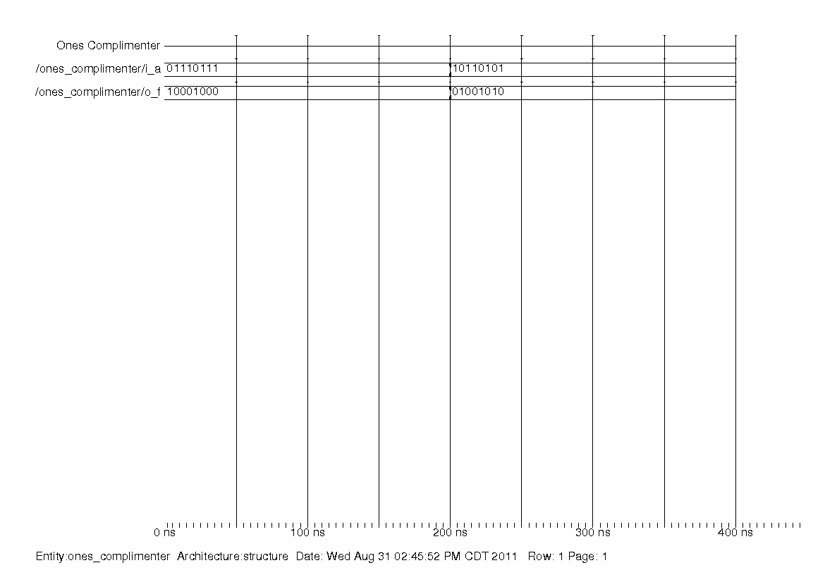
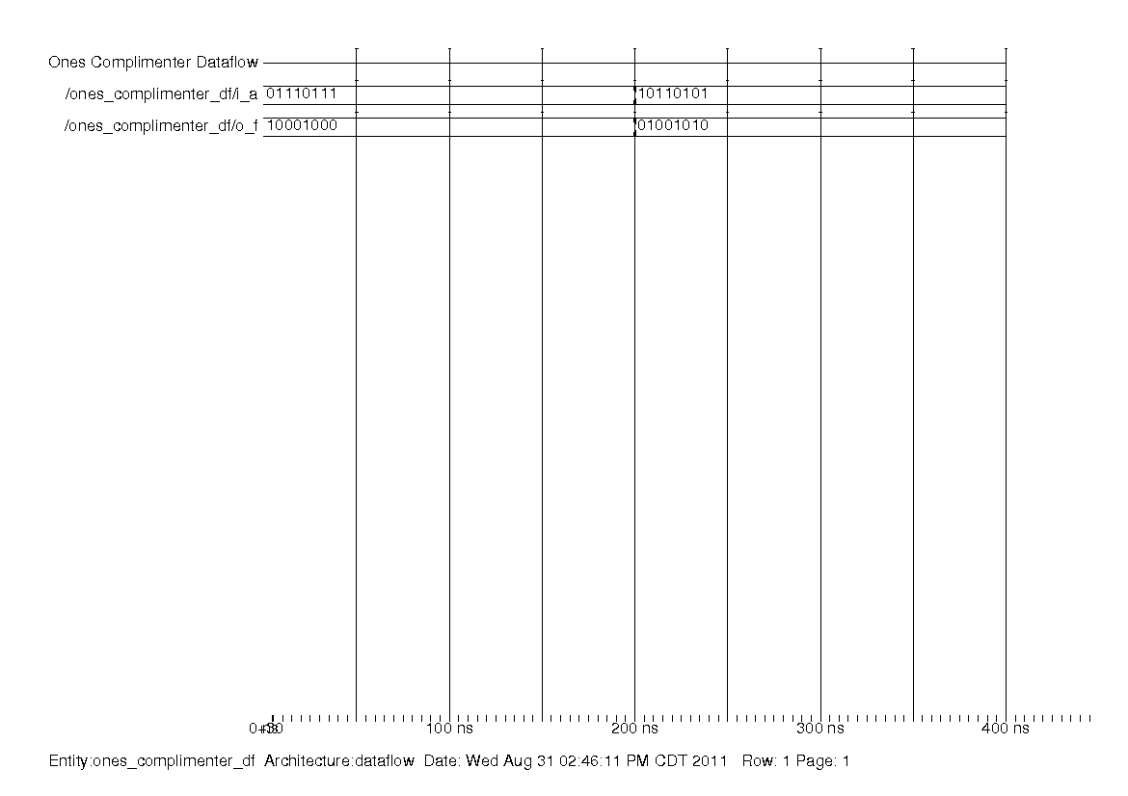
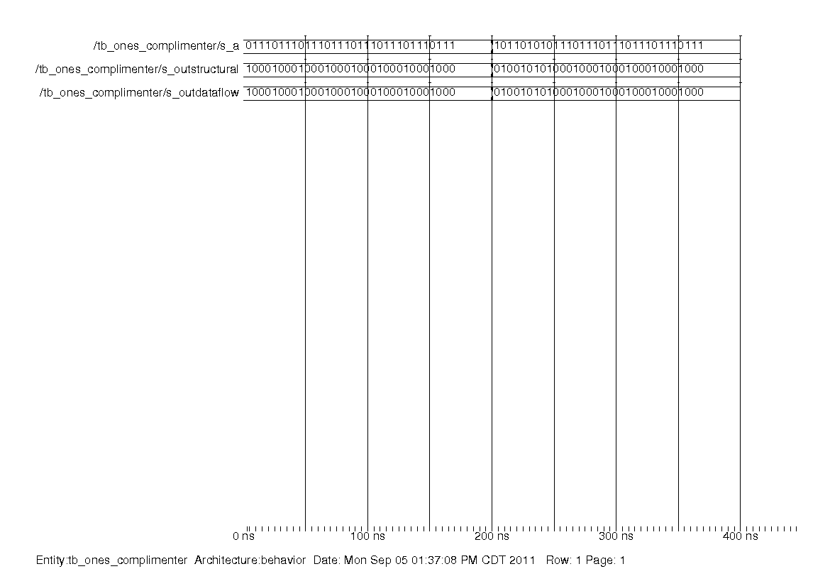
These are a collection of waveforms for the one’s complimenter. From looking at the waveforms, you can tell that it is behaving as expected (it is properly inverting bits).
Two-Input Mux
S | A | B | Out
0 | 0 | 0 | 0
0 | 0 | 1 | 1
0 | 1 | 0 | 0
0 | 1 | 1 | 1
1 | 0 | 0 | 0
1 | 0 | 1 | 0
1 | 1 | 0 | 1
1 | 1 | 1 | 1

Expression: S * A + ~S * B

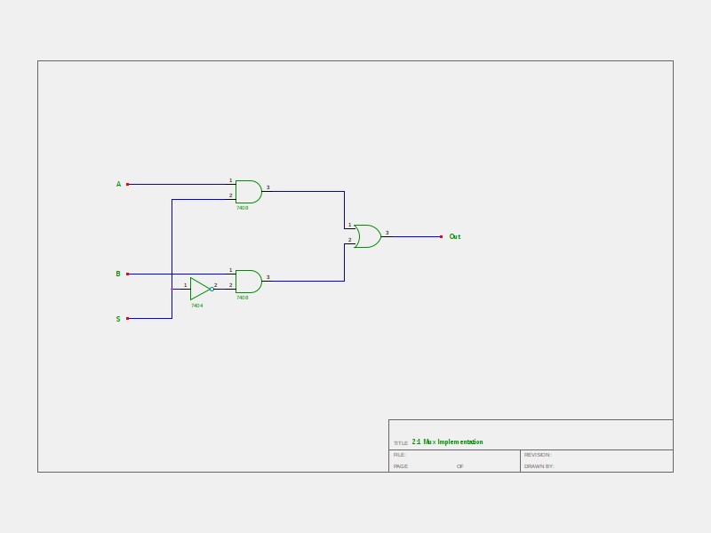
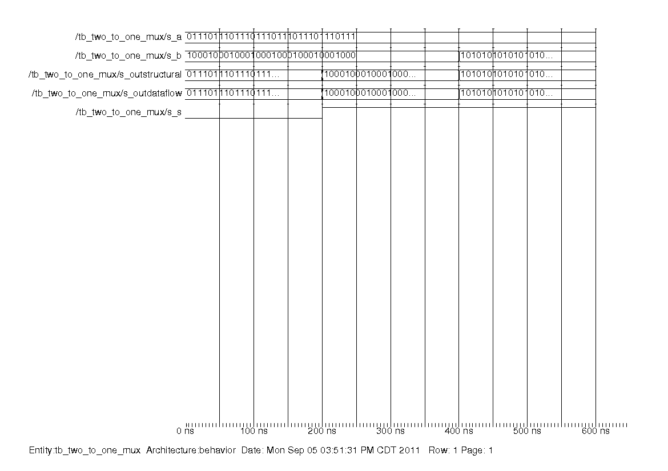
Full Adder

X | Y | Cin | Cout | S
0 | 0 | 0 | 0 | 0
0 | 0 | 1 | 0 | 1
0 | 1 | 0 | 0 | 1
0 | 1 | 1 | 1 | 0
1 | 0 | 0 | 0 | 1
1 | 0 | 1 | 1 | 0
1 | 1 | 0 | 1 | 0
1 | 1 | 1 | 1 | 1

Expression: S = ~X * ~Y * C + ~X * Y * ~C + X * ~Y * ~C + X * Y * C = X xor Y xor C
Cout = Y * C + X * C + X * Y = (Y xor X) * C + X * Y

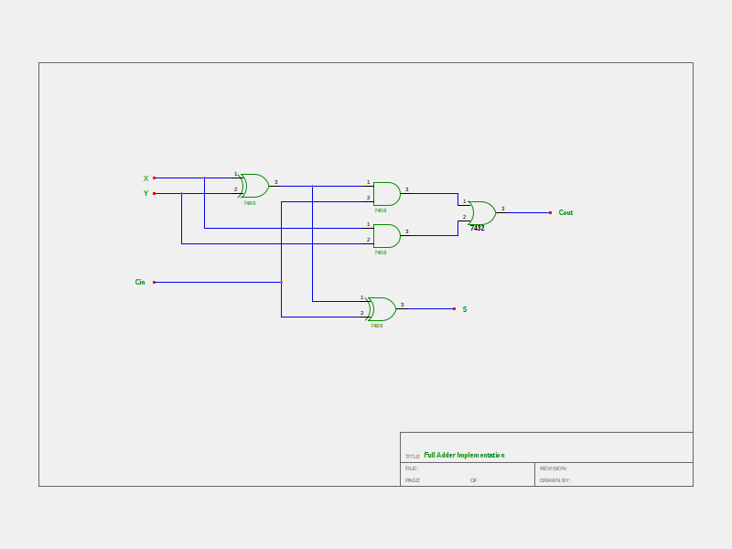
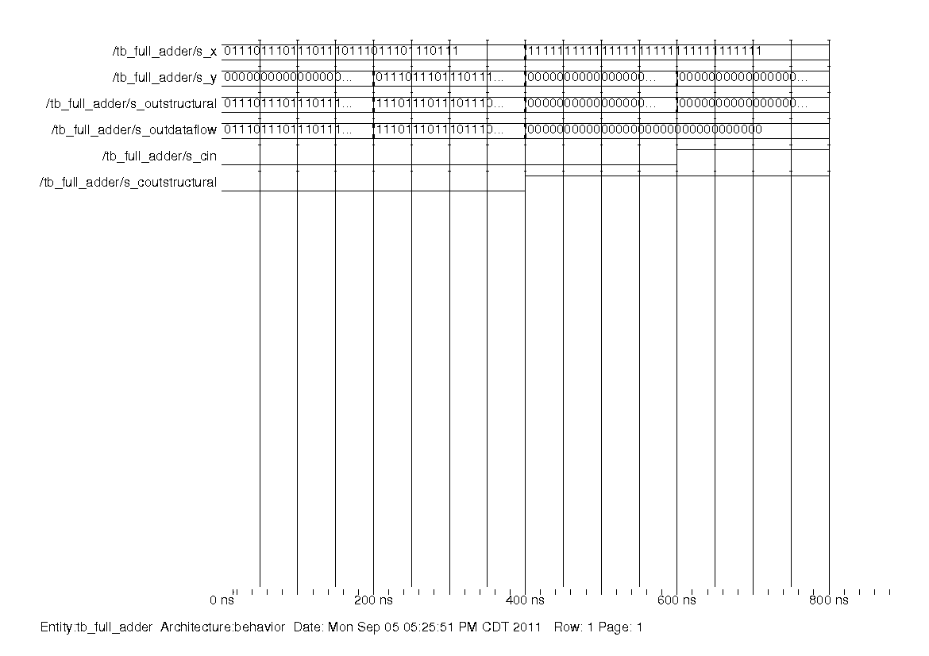
Adder/Subtracter with Control

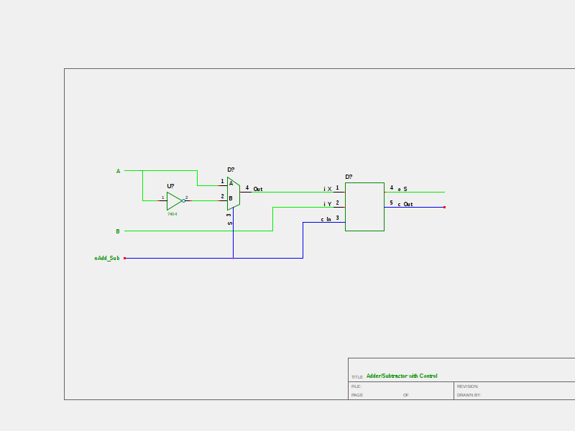
This design uses an N-bit Adder, an N-bit 2:1 Mux and an N-bit inverter. If nAdd_Sub = 0, the mux will provide A to the adder, making it perform A + B. If nAdd_Sub = 1, the mux will give the adder the inverse of A (by using the N-bit inverter). It will also pass along 1 to the adder as the carry in bit, which causes it to perform the equivalent of A – B.
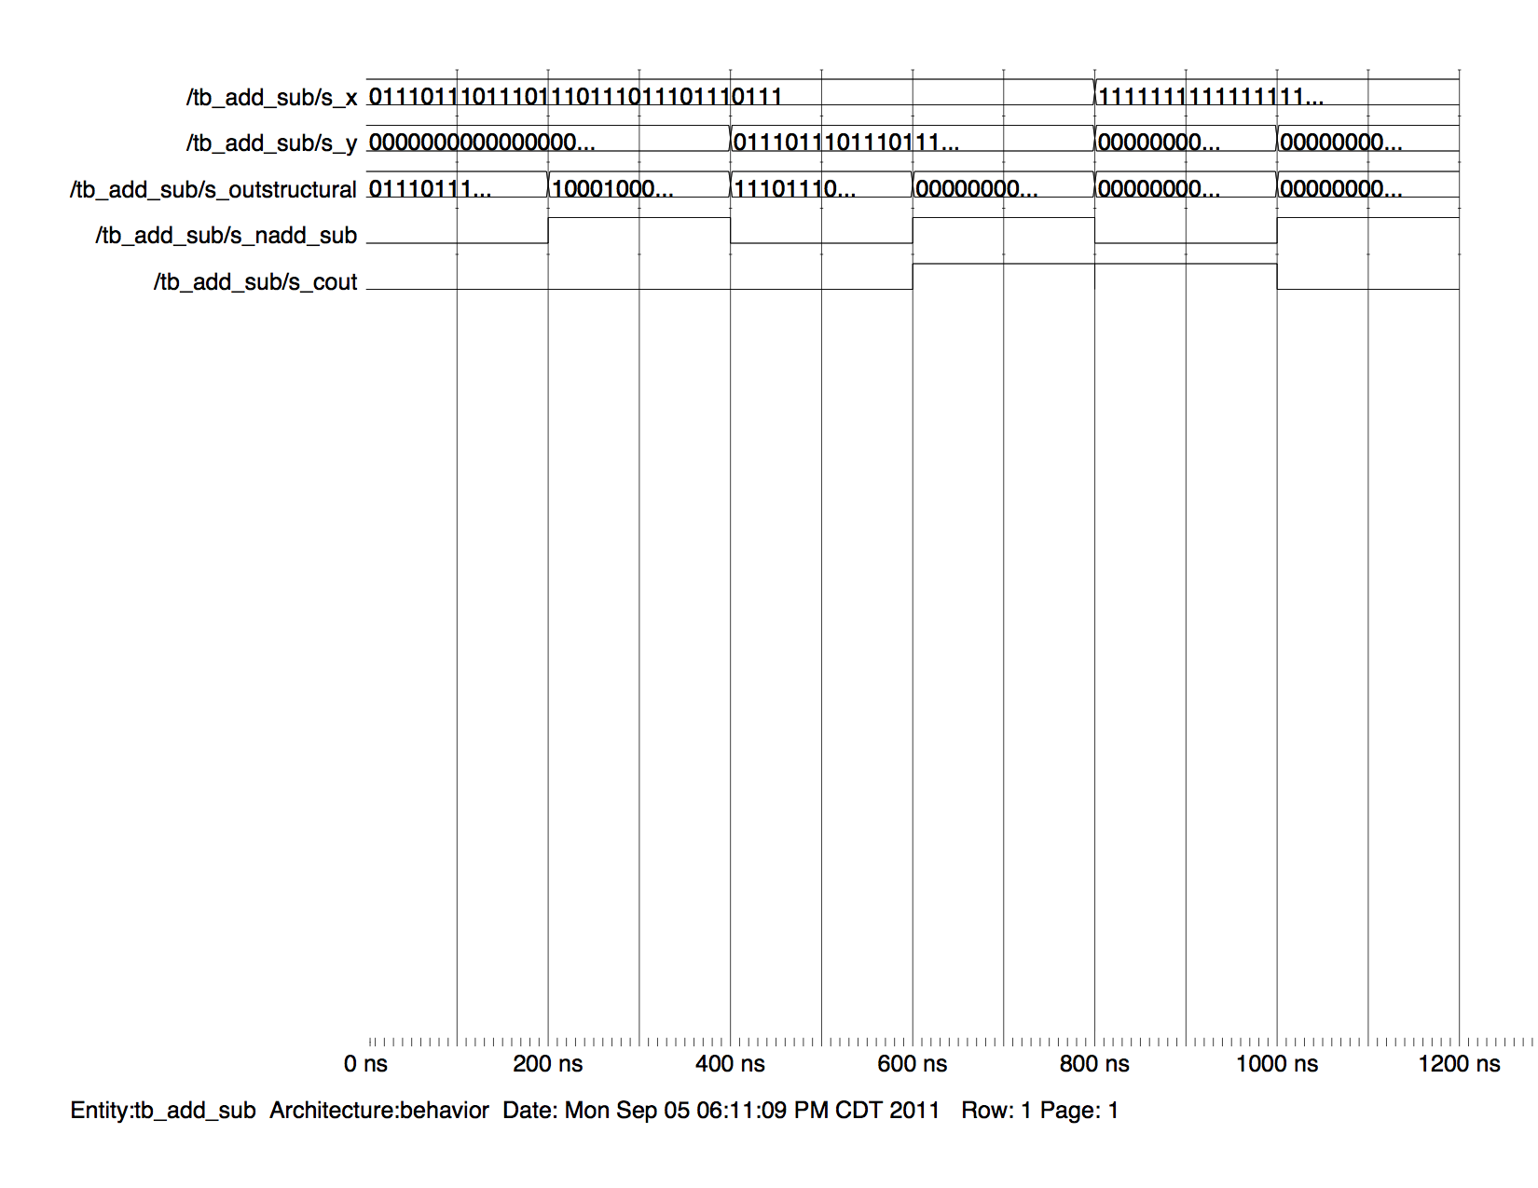
In this waveform, I have tested multiple values for the adder/subtracter unit. I tried to make test cases which would test different aspects of addition and subtraction including adding a positive and a negative number, subtracting a value from itself, adding two positive values, adding to make it overflow. See the tb_add_sub.vhd file for all of the values used, and their expected results.

